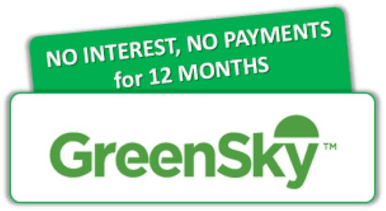

GreenSky Financing
To call you will need the following information. It only takes about 10 minutes to set up.

Call 866-936-0602.

Dial Option 1 for customer, and Option 2 for New Customer

Merchant Number: 81061010,

Select Plan 2521 is the plan with the Zero Down, 12 months with no interest. It is a 7-year term loan.

Please call Lisa at 616-649-8079 if you want other financing terms.

Our goal is to give you quick and easy option to finance your new HVAC equipment, with the option of being able to pay as much as you can in 12 months without penalty.

